**Name: _______________________________________**

**Python Activity 3: Arithmetic Operations and Assignment Statements**

|  |
| --- |
| **Learning Objectives**  Students will be able to:  *Content:*   * Explain each Python arithmetic operator * Explain the meaning and use of an **assignment statement** * Review **string literals**  and print statements * Explain the use of “+” and “*” with strings and numbers * Use the **int()** and **float()** functions to convert string input to numbers for computation * Incorporate numeric formatting into print statements * Recognize the four main operations of a computer within a simple Python program   *Process:*   * Create **input** statements in Python * Create *Python* code that performs mathematical and string operations * Create *Python* code that uses assignment statements * Create *Python*  code that formats numeric output   **Prior Knowledge**   * Material covered in previous Activities |

**Critical Thinking Questions**

1. Execute the print statements in the Python program. What is the output for each statement?

19

13

48

4096

5.333333333333333

5

1

1. State the arithmetic operation each symbol represents:

a. + Addition

b. - Subtraction

c. * Multiplication

d. ** Exponents

e. / Division

f. // Divides without remainder INT only answers

g. % Remainder

|  |
| --- |
| **FYI:** An **assignment statement** is a line of code that uses a “=” sign. The statement stores the result of an operation performed on the right-hand side of the sign into the variable memory location on the lef0hand side. |

3. Enter and execute the following two lines of Python code:

**age = 15**

**print(“Your age is”, age)**

a. What does the ***assignment statement***: **age = 15** do?

It makes it so when you print the word age outside of quotes you get 15 not the word age,

b. What happens if you replace the comma (,) in the print statement with a plus sign (+) and execute the code again? Type error you can’t add str and int together

4. What is stored in memory after each assignment statement is executed?

|  |  |  |  |
| --- | --- | --- | --- |
| **Assignment Statement** |  | **Computer Memory** | |
| answer = 6 ** 2 + 3 * 4 // 2 |  | **answer** | 42 |
| final = answer % 4 |  | **final** | 2 |

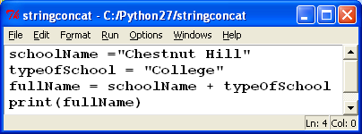5. Test the following program to see what happens if you try to use the “+” with strings instead of numbers.

a. The third line of code contains an assignment statement. What is stored in the variable **fullName** when the line is executed? Chestnut HillCollege. No space between hill and college._

b. How can you fix the output so that the words are separated? change “Chestnut Hill” to Chestnut Hill “

|  |
| --- |
| **FYI:** The “+” ***concatenates*** the two strings stored in the variables into one string. “+” can only be used when both operators are strings. |

c. What is the output of the following code? Why? TypeError for attempting to add str and

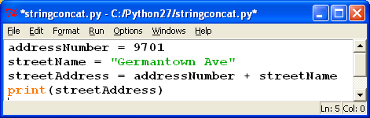

6. 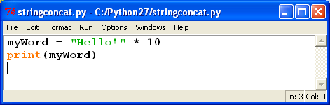Before entering the following code into the Python interpreter, try to figure out what **you think** the statement should print. Then execute it.

What does it do? Is this what you thought it would do?

**What you think it does: I think its going to print “Hello!” 10 times. Or have a massive stroke and give me an error**

**What it really does:** Pringts “Hello!” 10 times

7. Let’s take a look at a program that prompts the user for two numbers and subtracts them.

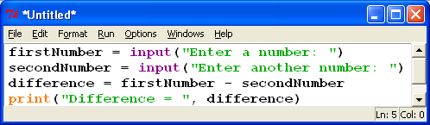

a. What output do you expect? “Enter a number” 10 “Enter another number” 6 “Difference = 4

b. Execute the code. What is the actual output?

Traceback (most recent call last):

File "C:/Users/cambu/OneDrive/Documents/Python/pp.py", line 3, in <module>

difference = firstNumber - secondNumber

TypeError: unsupported operand type(s) for -: 'str' and 'str'

c. Revise the program in the following manner:

* Between lines 2 and 3 add the following lines of code:

**num1 = int(firstNumber)**

**num2 = int(secondNumber)**

* Next, replace the statement:

**difference = firstNumber – secondNumber**

with the statement:

**difference = num1 – num2**

* Execute the program again. What output did you get? “Enter a number” 10 “Enter another number” 6 “Difference = 4

d. Explain the purpose of the function **int().**

You cant subtract str statements but you can subtract INT Statements

**Application Questions: Use the Python Interpreter to check your work**

1. Write the line of Python code that calculates and prints the answer to the following arithmetic expressions:

a. 8 to the 4th power print(8**4)

b. The sum of 5 and 6 multiplied by the quotient of 34 and 7 using floating point arithmetic

print(34/7*(5+6))

2. Write an assignment statement that stores the remainder obtained from dividing 87 and 8 in the variable *leftover*

print(87%8)

3. Assume: courseLabel = “CSC”

courseNumber = “152”

Write a line of Python code that concatenates the label with the number and stores the result in the variable *courseName*. Be sure that there is a space between the course label and the course number when they are concatenated.

courseLabel = "CSC"

courseNumber = "152"

courseName=(courseLabel + " " + courseNumber)

print(courseName)

4. Create a program the outputs the total cost of a lunch order. Users should be prompted to input the number of hamburgers, fries, and drinks they want and the program should print the total cost of the order. The hamburgers cost 2.00, fries cost 1.50, and drinks cost 1.00. Be creative and professional in prompting the user for the information and in displaying the output.

hamburgers = float(input("How many hamburgers would you like?: "))

fries=float(input("How many orders of fries would you like?: "))

drinks=float(input("How many drinks would you like?: "))

burgerCost=(hamburgers*2.00)

fryCost=(fries*1.50)

drinkCost=(drinks*1.00)

totalCost=(burgerCost+fryCost+drinkCost)

print(totalCost), print("cents Is your total.")